**COG Auto Fill Extension (Adding new regular expression)**

Hello, Sam.

This document shows how you can add a new regular expression in to Cooking on Gas auto fill extension.  
The regular expressions variables are in the base.js file of backend folder.

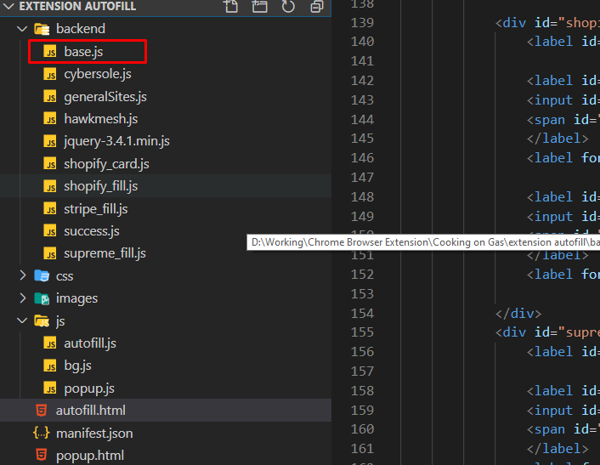

Please open the base.js file in visual studio code like the picture above.

You can see the RegExp variables like following picture.  
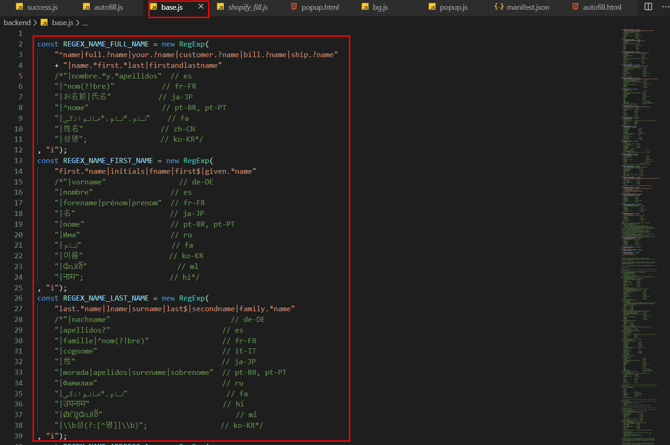

For example, let’s assume we are trying to add firstname and fname into REGEX_NAME_FIRST_NAME variable.  
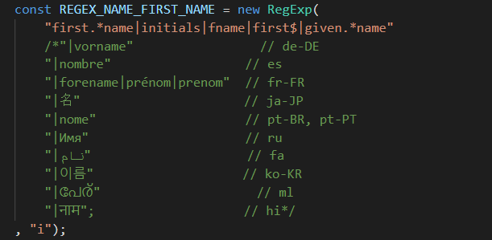  
  
The above picture shows the current value of this first name regex variable.

You can add the firstname and fname into this variable using ‘|’ sign like following.  
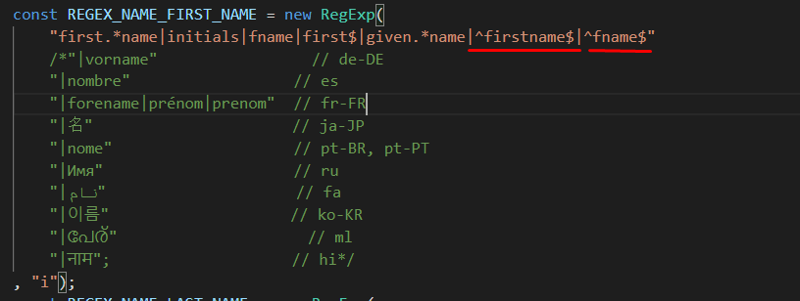

You can erase the ^ and $ symbol of the start and end of values. The following case shows meaning of this symbols.

/^firstname$/.match(“firstname”) => true;

/^firstname$/.match(“firstnames”) => false;

/^firstname/.match(“firstnames”) => true;

/firstname$/.match(“firstnames”) =>false;

/firstname/.match(“afirstnames”) =>true;

Thank you for reading my notes. : )